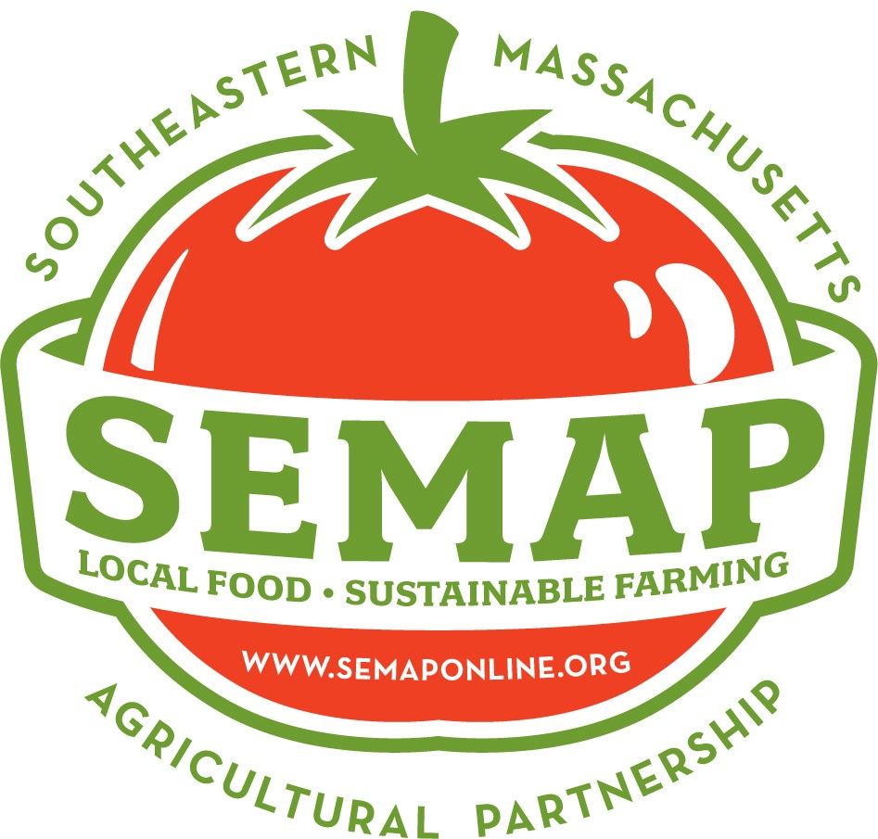
SEMAP is a 501c(3) non-profit, member-driven organization. Please consider becoming a member today. Your tax-deductible contribution is a key to keeping our programs going. Through membership you receive the benefit of contributing to a strong, thriving local food economy. Join us as we help ensure a positive future for agriculture in our region.
SOUTHEASTERN MASSACHUSETTS
AGRICULTURAL PARTNERSHIP
P.O. Box 80625
South Dartmouth, MA 02748
www.semaponline.org

Benefits of membership:
- Supporting a vibrant local food system in Southeastern Massachusetts
- All SEMAP members receive discounts to SEMAP events, workshops, and Ag & Food Conference
- All SEMAP members will be listed on our website
- Businesses may request a Buy Fresh, Buy Local Marketing Kit
- Sponsors receive recognition at all major SEMAP events

Business Membership Levels and Annual Dues
Please submit your membership dues by March 15th to be placed in the SEMAP Local Food Guide
Circle one:
$75 – Small/Beginning Farm/Local Food Business
$150 – Mid-Sized/Large Farm/Local Food Business
$500 – Sponsor – Quarter page ad in SEMAP’s Local Food Guide
$1000 – Half page ad in SEMAP’s Local Food Guide

Individual and Family Membership Levels and Annual Dues
All individuals are listed on our website and will be signed up to receive our monthly newsletter
Circle one:
$15 – A great chance to contribute if you haven’t joined as a member before!
$40
$75
$250 – SEMAP stickers + shopping tote bag + special recognition
$500 – SEMAP stickers + shopping bag + special recognition

Name:
Farm/Business Name:
Mailing Address:
Phone:
Physical Location (If different):
Email:

___Check Enclosed
___I would like a Buy Fresh, Buy Local Marketing Kit (farm/business members)
___Please do not publically list my membership

