Gardens by the Sea:
a Community Garden Startup Guide for the Southcoast
Written by Reba Elbourn

Table of Contents

Benefits of Community Gardens 3
An Oversimplified Step-By-Step Guide 5
Where to Begin 6
Talking to Your Community 6
Picking a Location 7
Getting Permissions 7
Designing 8
Essentials 8
Structures 9
Garden Bed Tutorial 10
Amenities 11
Funding 12
Group Funding 12
Sponsors and Grants 12
Fundraisers 13
Building 14
Planting 15
Fruits and Veggies 15
Flowers 15
Native Species 16
Management 17
Communications 17
Security 17
Group Tasks 18
Conflict Resolution 21
Important People 21
Quick Resources 23
Sources 25

The Benefits of Community Gardens

Gardening as a hobby skyrocketed at the beginning of COVID19, thanks to a combination of factors like extra time at home from the shutdown, concerns over the supply chain itself and virus exposure along the line, and feelings of isolation and cabin-fever. Gardening was a safe way to get outside and soak up some sunshine and alleviate some of the mental and emotional strain of quarantine. (UCANR) According to a survey by Scott’s Miracle-Gro, more than half of Americans are now gardening or caring for their lawns in some capacity. 16 million new people began vegetable gardens around March 2020, and businesses recorded on average a 19% increase in transactions according to consumer research from GreenProfit. But what about the people without the luxury of a home with a yard, lawn, or even a patio?
Houseplants and attaining the title of “Plant Mom” are trending, too, but these indoor gardens often within the home don’t meet the same needs that one can achieve with an outdoor space. There are many barriers that people can face when trying to start a garden even if they do have access to a yard, especially renters, who on average hold almost 1469% less household wealth than homeowners, excluding their home equity. With home equity included, the ratio is closer to 4000%. (US Census 2017) This disparity makes renters much more vulnerable to many of the risks that are driving people to start gardens, namely food access.
Food access, and especially access to healthy, fresh, fruits and vegetables are one of the main benefits of gardens. There is increasing scientific evidence that gardening and exposure to green spaces improve mental health (Thompson, 2018), and working, moving, and being outside improves physical health. Growing your own fruits and vegetables and having fresh-off-the-vine food, which tastes so much better and is more nutrient-dense, also translates into having healthier diets, since people typically want to eat the “fruits of their labor.”
Community gardens help make all of these benefits more accessible to people who are unable to access a space to garden for socioeconomic or disability status, along with many other reasons. 22% of the respondents to the Miracle-Gro survey reported that they participated in community gardens, which provided a semi-safe way to get vital social interaction from a safe distance of 6 feet away during the pandemic. Many people reported feelings of depression, isolation, and stress during the pandemic, which community gardening provided extra relief for. Continued safe socializing now that pandemic restrictions are being lifted will provide the essential community ties for resiliency in the wake of the economic consequences of COVID19.
Other benefits of community gardens include improving the environment for more than just the sake of beauty. Sustainably managed community gardens can help increase biodiversity and help save threatened species like bees, butterflies, and other important pollinators. Having more plants in the ground also helps filter pollutants out of groundwater and sequester carbon from the atmosphere. Phytotechnologies and phytoremediation methods deliberately use plants to absorb toxins in some contaminated sites and can be an effective way to clean up brownfields (EPA), of which there are many in Southcoast cities.
According to Southcoast Health’s Community Needs Assessment of 2019, some of the main concerns for improving community well-being include behavioral health services, chronic disease prevention and treatment, and health disparities from social determinants like income level, education level, race, and gender. The benefits of community gardens can provide some small solutions to all of these issues that we are facing in the region.
Bristol County also has the highest rate of food insecurity in the state, which ranks 5th in the entire United States. More than 1 out of 10 people here lack the ability to get enough nutritious food for an active and healthy lifestyle, this number dramatically increases when you look at demographics for children, minorities, and disabled folks. Part of this problem that is noted is the issue of food deserts, or “areas that lack fresh fruits, vegetables, and other wholesome foods,” as defined by the American Nutrition Association. The highlighted green areas in the figure below indicate food deserts in Bristol County. These areas are often densely populated, low income, and lack grocery stores within 1 miles (in urban areas). Community gardens in these areas specifically would help boost the nutrition and overall physical and mental health of the neighborhoods by providing access to fresh food, beautiful green spaces, and community ties.
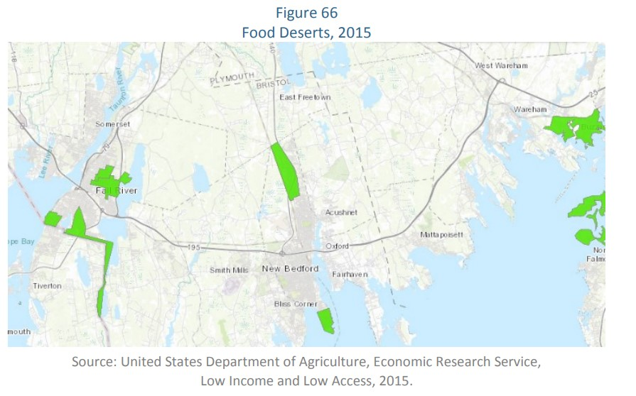
Oversimplified Step By Step Summary:

- Talk to your neighbors and see if there is true interest in a community garden

- Find a suitable spot to put a garden and get permissions to put it there

- Design the garden and figure out what your community wants in it to make it functional

- Figure out your budget based on this design and how you will pay for the start-up costs

- Purchase your building materials and start making your community garden!

Where to Begin

Talking to Your Community
Each community garden is unique because it is shaped around the needs and goals of the community in which it resides. Not every community garden is based around the typical plot-rental system that is widely used. A community garden can be a large, multi-acre farm that grows thousands of pounds of food to donate to charity, student-powered school gardens that grow food for the cafeteria, or it can be just a few raised beds in a senior center used to grow beautiful flowers to brighten up the space. The best way to figure out what your community garden will look like and how it will run is to talk to your neighbors!
Starting up a conversation with your neighbors will help you figure out very quickly if a community garden is even feasible. If no one in your community wants to garden, or has concerns about it, or prefers their own yards or patios to garden, then you may want to reconsider. Not every community wants or needs a community garden, so going through all of the effort of building one and assuming that the gardeners will come to you can turn out very disappointing. On the contrary, you may find that many people are enthusiastic about a garden and are willing to help you put in the work that needs to be done to get the job done! Help from your community is vital in shaping the vision and the reality of a community garden, so don’t go it alone! Some ideas on how to reach out to your community:
- Go door to door and ask your neighbors directly
- Post on social media and in location-specific groups and pages for your area about the idea
- Bring up the idea in any neighborhood, PTA, or condo-association meetings.
- Organize your own virtual or in person meeting to discuss the possibility of a community garden
  - Make posters/flyers advertising the meeting which can be posted in common or public areas like in shop windows, bulletin boards, or on telephone poles.
  - Make a separate email specifically for communications regarding the garden to offer people a way to contact you with questions or RSVP
- Email your coworkers or student peers and teachers
- Ask your school or local newspaper about publishing a small survey or press release regarding your community garden plans

Picking a Location
Once you know if you have the community support that you need, you will need to find a suitable place to start gardening! Consider the number of participants, as well as their needs and gardening goals. You’ll want to find a location that is central to your community, whether that be at a school, workplace, or a neighborhood. You want it to be easy and convenient to get to the garden, and accessible for everyone involved. You probably want to look for a sunny spot that get 8 hours of sunlight every day, but shade gardens and other areas can be made to work, as well. Potential spots for a garden could be in a vacant lot, a neighbor’s over-sized/underutilized plot, along walking paths or in parks, or even on cement parking lots, on roofs, or inside! Make sure to check on the history of the location with the town, as well, a vacant lot or field may be contaminated with toxic chemicals or debris from previous buildings there.
Getting Permissions
Take the same approach as when you talk to your neighbors, and just engage people in conversation when trying to get permission to use a site for a community garden. Getting permission is intertwined in the process of picking a location for the garden, so you may be looking for permission before you choose a location or vice versa. If you find a decent spot to have a garden, the best course of action is to just ask the landowner or property manager and see what they say. A neighbor with a large yard may be willing to lend you the use of the space in exchange for fresh produce from the garden, even if they aren’t particularly interested in gardening themselves. The realtor of a vacant lot for sale may lease the land for the garden for a small fee until something is scheduled to be built on the lot.
If your ideal location is in a park or on city land of some sort, you can reach out to your town’s Parks and Recreation Department to ask for permission to put a community garden on the plot. The Parks and Rec Department of New Bedford instructs people to put together a detailed proposal for your community garden plan, including the location of the garden, who will be managing and maintaining it, who will be benefitting from it, what materials or services will be required like water and electric service. The more detailed the better. Then, submit it to the department, who will review it and help clarify any missing information before it will be submitted to the Parks Board for approval. The Parks Board meets once a month, so the process can take a little longer to get an answer from the city rather than from a private land-owner. There is a detailed policy document on the city website under the Parks and Recreation department’s “Rules and Ordinances” page that outlines the steps required.
There are 20 community gardens in New Bedford, so the city is very supportive of infrastructure proposals like these that improve community health. Their main concern is what happens to the gardens if they need to be disassembled in the future due to lack of use, so if you include these practical, long-term details in your plan it will show that thorough research and thought was put into your proposal, increasing the likelihood of receiving approval.
Designing

Essentials
The absolute essentials of plant life are sunlight, soil, and water. If you’ve picked a good sunny spot, then that should be pretty easy to come by. The Earth is hit by 173,000 terawatts (trillions of watts) of solar energy strikes the Earth continuously, so there is plenty to share. If your garden will be inside or in an area with insufficient lighting, then you can supplement sunlight with electrical grow-lights or adapt your plant selection for the gardens to be shade-tolerant.
Soil is another matter, and there are several things you can do to ensure that you have good quality soil with nutrients for your plants.
You can check on the USDA’s Web Soil Survey website to see the soil types in your location to get an overview of the soil horizons (layers of soil).
If you’re unsure or there’s not any data listed for your spot, then you can get the soil tested by UMass Amherst’s extension service. To take a sample, use a “clean bucket and a spade (…) to collect 12 or more subsamples to a depth of six to eight inches (…) from random spots within the defined area.” (UMass Amherst Extension Service) Then you break up clumps and mix the samples together, and scoop out 1 cup of the soil which is then spread out and left to dry before collecting and labeling the sample in a zip-lock bag for submission.
If you are using raised beds or containers of some sort, then the quality of the soil (or lack thereof) matters a lot less. You can order soil in bulk from garden centers and farming supply stores, refer to the Resource section of the guide for local suppliers of soil and other useful items. You’ll want to fill raised bed with about 40% bulk or top soil, 40% compost, and 20% aeration components like perlite, coarse sand, pumice, or lava rock. If your beds are very deep you can fill the bottom quarter with wood and branches, which will break down over time. This mixture will help keep costs down when compared to filling the beds with 100% potting soil, and provide a good texture for plant roots.
Water is most often the hardest element to acquire for community gardens, and one of the largest expenses. If there is no water access nearby, like a spigot for a hose, you will have to figure out how to get it there so that it is easy for gardeners to water their plants. You may need to install a spigot on the outside of a building, get permission to use a spigot from a neighboring building, home, or business, or build a rain-water catch system. A quote from a local plumber for a simple exterior spigot installation amounted to 200-240$, while installing a new waterline to go out through a field can cost several thousand dollars.
You can also build a rainwater collection system with large barrels and PVC pipes to collect water from rain spouts, or if no roof or rainspout is available, you can use tarps tied up at an angle to direct rainfall into the barrels. New Bedford, MA, gets about 24 inches of rain annually, and it is perfectly legal in Massachusetts to collect rainwater, so make use of the Earth’s hydrological cycles and save money on the water bill!

Structures
Garden beds are the most essential thing you need in a garden, a place prepared to grow plants! It can be as simple as a tilled in-ground bed, or as elaborate as a hydro or aquaponics system if that’s what suits your community garden. Some examples of different garden beds include raised box beds, elevated garden boxes, hanging baskets, and containers, buckets, and pots. Pick the method that best fits your space.
Here are some instructions for building a simple, 1 foot tall, raised garden bed:
See diagram on next page.
What you need:
4 (1”x6”x6’ wooden boards) (A)
4 (1”x6”x3’ wooden boards) (B)
6 (2”x2”x1’ wooden blocks) (C)
(Screws or nails, 2-2 ½” long preferably) (D)
(Drill, hammer, or screwdriver)
Optional: (Saw, newspaper/cardboard or landscaping fabric)
*If you don’t have a saw or access to one, you can get the wood pre-cut to the lengths you want at a hardware or lumber store. These are just suggested lengths, you can customize this design to make the bed taller or longer or shorter, or just use what you have available and apply the same principles if the size of the bed isn’t too important to fit your space. Wooden pallets are often cheap or free, check with local businesses to see if they have any that they are trying to get rid of!
Step 1: Lay down 3 of the 2”x2” wooden blocks 3 feet apart and then the 2 long boards (1”x6”x6’) side by side perpendicular across the 3 blocks as shown in the diagram and attach the boards with 2 nails each to the wooden blocks at the 3 junctions*, using a total of 12 nails. Repeat this with the other 3 2”x2” blocks and the other 2 1”x6” boards.
*Hammer the nails in from the plank side through to the block, especially if your nails are shorter than 2 ½”.
*Make sure the end blocks are flush (lined up so that the surfaces are flat) with the edge of the planks for the next step.
Step 2: Set these up on their sides with the shorter planks perpendicular, and hammer nails into the shorter planks through into the wooden blocks on the ends of the long sides.
Step 3: Place beds in desired location, line bottom with newspaper, cardboard, or landscaping fabric to block out and kill any weeds or grass underneath the box. Then fill with soil!
To calculate how much soil you will need, multiply the length by the width of your bed, and then multiply the depth you want to cover. This bed requires 18 cubic feet of soil to fill to the brim, but you can get away with a depth of 8-10 inches of soil and only need 15 cubic feet.
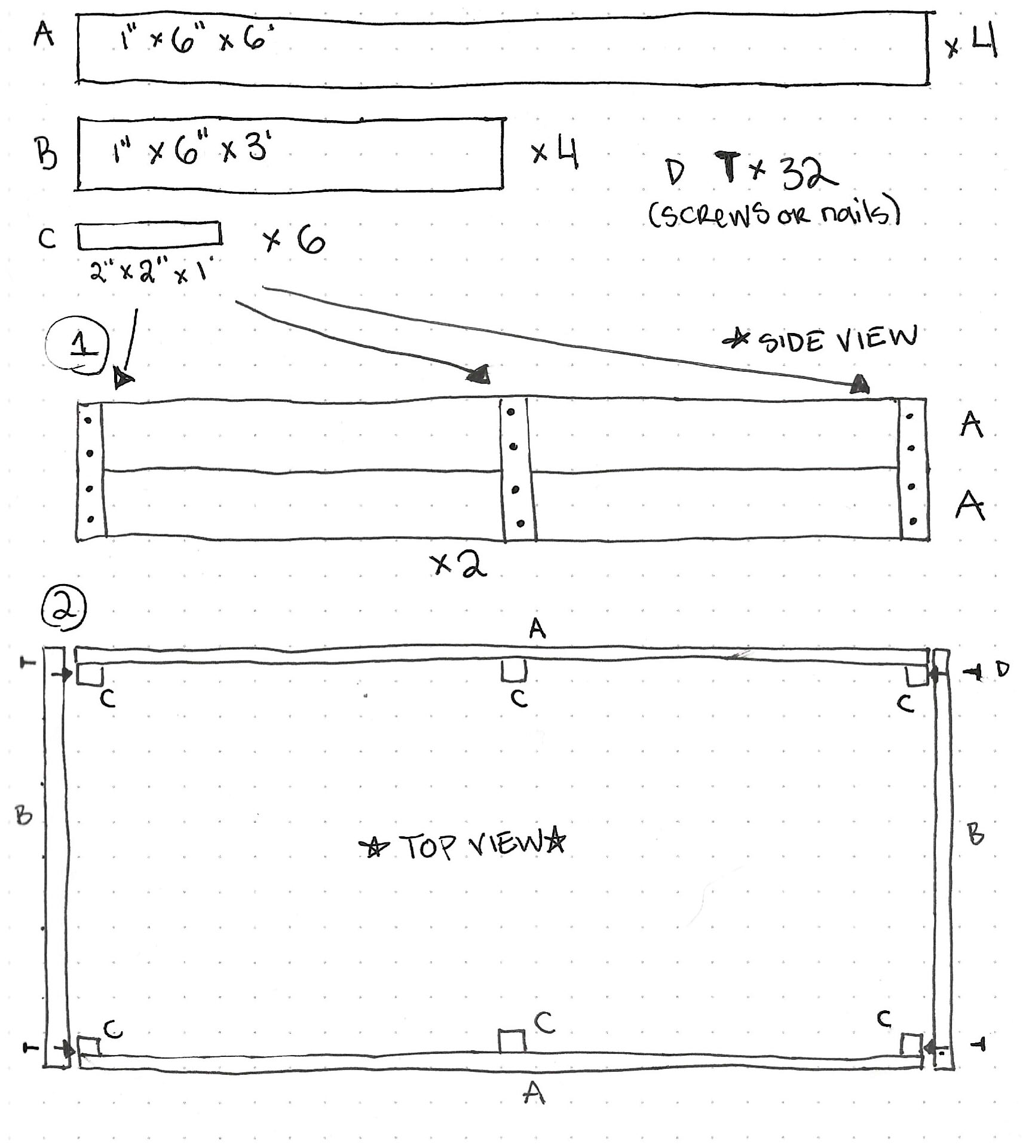

If you don’t have much building experience, you can often get easy to assemble garden bed kits from garden centers and hardware stores. Grow Greater New Bedford is a local non-profit organization that will help you build garden beds at no cost, too!
After you have your beds in place, you can start gardening! But you may have problems with pests eating your veggies and may want to consider adding a fence. You can install a fence around the individual beds, or around the whole garden. Chicken wire with a mesh size 1” or less will keep most small mammals like bunnies and gophers out, but for other animals that climb or leap like squirrels, raccoons, and deer, those will need taller and more secure fencing. Fences are often a large expense, and most gardens start out without them. Permanent fences often need permits to construct and must meet certain codes depending on the zone-type of the property, and even the spot on the property that you plan on building on, so check with your city’s building inspector or city hall.
Compost bins are another great addition to gardens, and help cut down on costs for soil amendments as well as reducing food waste. There are all kinds of ways to compost your food scraps and turn them into nutrient-rich soil, from small, counter-top compost buckets designed for indoor use, to using earthworms to digest the food, to just piling it all up in a corner of the yard and letting it sit. You can buy large, plastic compost bins that keep pests, rain, and sun OUT and the smell IN. Or you can build your own multi-compartment composting system cheaply out of wood and chicken wire: these can produce a lot more but it takes a lot longer. These can also be hard to manage with large community gardens and making sure everyone is educated about what can and should go into the compost bin is crucial to keeping it healthy, operational, and not stinky. Composting deserves its own guide, but there are plenty of resources out there already on composting. See the resource section at the end of the guide for suggestions.
Tool storage is another consideration for structures to include in your community garden. If you want to provide tools for people to use and share, you will have to have some place to keep them out of the rain and snow when not in use. A heavy chest, perhaps attached to a fence post to prevent theft can be used, or a whole shed, depending on the amount and size of your community tools. Larger tools can often be borrowed or rented from other community gardens, neighbors, or businesses.
Amenities
Other things that could be nice to include in your garden design include chairs, picnic tables, and arbors for shade and rest spots. These touches aren’t necessary but can make the garden a nice place to just hang out and enjoy the beauty of the plants. Building a small community pantry or cabinet where people can leave excess fruits and veggies from bumper crop harvests for others is a fun idea to both promote the garden and its goodies to your neighbors and also reduce food waste from crops that would otherwise rot in the plots. Art projects from local artists or children can beautify the space even more and showcase the unique flair of the community. One community garden even built an outdoor clay oven. The possibilities are endless!
Funding

Community gardens will require some money to start and sustain the project, but don’t feel like you have to go it alone and spend all of your own personal funds to invest in the startup of a community garden. There are plenty of ways to acquire funding for materials and expenses needed to start your project. This is another integral part of the “community” aspect of the garden, you will want to turn to your community and ask for them to invest in the shared space you are initiating.
Group Funded
This is the simplest way to fund a garden startup. Determine the materials you need, get a price for that amount, and then split the cost in cash with the other interested community gardeners. After the startup costs are paid for, many community gardens charge a fee to use their plots on a seasonal or yearly basis and use this income to pay for upkeep costs like mulching pathways, replacing rotted wooden beds, buying new shared tools for the garden, and even expanding the garden’s amenities. Using good communication and record keeping is crucial for this method but avoids paperwork.
Sponsors and Grants
If the people directly involved in the garden can’t cover the startup costs between themselves out of pocket, then another option is to approach organizations for sponsorships and apply for grants offered by local organizations. Local businesses, churches, non-profits, clubs, schools, and local governmental bodies may be able to contribute cash or donate materials or other benefits in exchange for a plaque or a sign in the garden acknowledging their support!
Consider larger local employers to approach for cash donations and sponsorships, as many larger businesses already have funds allocated to give back to their community in some way. Some businesses like BayCoast bank offer easy online applications while others require a formal request mailed to a P.O. box, and some may be able to offer in-kind donations as well on a case-by-case basis. Going through the process of reaching out to businesses and applying for these types of sponsorships is worth the effort because you’ll never know if you never ask.
Smaller local businesses may also be able and willing to offer more in-kind donations of building materials, transportation, and even labor as a way to give back to the community.
You can even apply for grants from the city and state government agencies and other organizations like the United Way Changemaker grant, which doesn’t require you to be a 501C-3 non-profit organization to receive funding. Involving multiple branches of your surrounding community enhances the strength and interconnectedness of your community ties, so reaching out to multiple types of organizations is a great way to cover the different kinds of expenses that a community garden will incur.

Fundraisers
Another way to raise the money needed for a community garden is to make the money yourself by throwing fundraising events. Coordinate with your gardeners and community members to run an event or a sale to make some cash to use for materials and equipment for your community garden!
When thinking of fundraisers, the first thing in most peoples minds is the good, old fashioned bake sale. This can work, or for those less skilled in the kitchen and more in the garden: you can coordinate for several members to grow some seedlings for cheap from seed, and have a plant sale!
If you want to approach local businesses, some of them may be willing to donate products or inventory that you can use to raffle. This way, even if a business can’t sponsor your garden or provide relevant in-kind donations, they can still support your fundraising event.
GoFundMe, Kickstarter, and other online fundraising websites can be very valuable fundraising tools. If a lot of people share it on the internet through various social media outlets, your community involvement can have an even farther reach and garner support from friends, family, neighbors, and even strangers who want to promote the founding of more community gardens.
Some other ideas for raising funds include hosting a dinner party or a picnic, which might be a better tool for fundraising down the line after the garden is more established—then you can use your home-grown produce. But it’s still quite doable for start-up stages, as well! Sell tickets to the meal for enough to cover the costs of food, plus some profit to go towards the community garden.
Depending on the community’s range of talents and skills, there are any number of events that could be organized as a fundraiser for the garden. Talent shows, sports games, water-balloon fights, cooking competitions, movie nights, art shows or auctions, yard sales, board game nights, or even a small musical concert are all great ways to involve your community in the creation of and the project.

Building
Sourcing Materials
Reaching out to other community gardens in your area can be a great way to form a connection with people who are already totally on-board with the concept of community gardens. They are often ready, willing, and enthusiastic to help in any way that they can. This includes lending tools and equipment, plant starts, and invaluable advice for newbies.
Other great places to get some common gardening items, and some not-so-common, include:

The Great American Rain Barrel Company (Rain barrels)
Greater New Bedford Regional Refuse Management District (Compost barrels)
Black Earth Compost (Buy Compost and Compost Disposal/Processing Services)
Marvin Grain and Hardware Co (South Dartmouth)
Mahoney’s Garden Center
Bridgewater Farm Supply
Oliveira Brothers Materials Inc
Country Hardware, Acushnet, MA. (508) 995-4272
King Farm, Dartmouth, MA. (Compost)
Kenny’s Garden Center, Fairhaven, MA. (508) 999-5579
Klein Greenhouse, New Bedford, MA.
Confreda’s Farm, Cranston, RI.

-Even big chain stores like Home Depot and Lowe’s sometimes offer discounts for non-profit organizations and small groups doing community-improvement projects like community gardens.

Planting
Included below are some resources on basic gardening knowledge, and links to more in-depth guides focusing more on how to grow plants.
Most of Bristol County is in hardiness zone 6b or 7a. The average last frost date falls between April 15th and May 10th, while the average first frost date falls between October 21st and November 10th. Keep these dates in mind to plan plantings. Here are some free online tools to help you decide what and when to plant.
Plantmaps.com has useful map tools with more relevant climate information.
Frostdate.com
Farmer’s Almanac Plant Calendar
UMass Amherst Home, Lawn, and Garden Fact Sheets
Beginner Gardening Tips

Fruits, Veggies, and Herbs
Many people garden to grow fresh food and have more control over how that food is produced. Fresh food right out of the garden tastes better and is more nutritious than most produce found on grocery store shelves, because it is usually consumed in a shorter timeframe post-harvest.
New England Vegetable Management Guide (Highly in-depth 344 page guide created through cooperation of the extension vegetable programs of the New England state universities.)
Soil Basics (Recommended information by the Massachusetts Master Gardener Association)

Flowers
Some people like to grow flowers in their garden for their beautiful appearance and scent, as well as for some medicinal uses. Flowers are a popular pick for people who want to save the bees and provide habitat and food sources for beneficial organisms and insects in the garden.
Plant Something MA Plant for Pollinators

Natives
Planting native species is a great way to help regenerate ecosystems and support biodiversity, as well as to stand out from the rest of the crowd with uncommon decorative and edible plants. This section also includes information on invasive species that can threaten native organisms and degrade and destabilize local ecosystems if planted.
Grow Native Massachusetts
Native Plant Finder
Go Botany: Native Plant Trust Plant Identification
Massachusetts Introduced Pests Outreach Project (Invasive Species Information)

Whatever you choose to grow, and any combination thereof, will help make your experience gardening more educational and fun as you learn the ways of each different plant. See the Quick Resources section for more information on gardening and where to get seeds!

Garden Management
The work doesn’t stop once you have your garden built and planted, there are some things that must be done on top of the regular garden maintenance. Community gardens are run by multiple or many people who will need to work together to tackle tasks that are too big for individuals alone, and require certain skills in communication and conflict solving for instances when problem arise.
Communication
You will need to figure out a way to communicate with your fellow gardeners in order to organize times for meetings and group tasks, as well as keep an open line of contact for people to ask questions and figure out answers together. Find a form of communication that works best and is accessible for everyone in the garden group. Here are some suggestions on how to establish good communication for your gardening group.
- Social media (An official community garden page/group can act as a bulletin board and discussion forum)
- Chatroom (like Discord, Slack, Microsoft Teams)
- Text (if everyone is comfortable sharing their phone numbers)
- Email (a benefit to this is that you can easily make a separate email account specifically for community garden communications to protect privacy)
- Zoom/ Virtual Meetings can accommodate people who may not be able to attend in person.
- Bulletin Board (A low tech solution for people without or without reliable access to phones/computers)
- A Notebook can be kept in a toolshed or other waterproof space in the garden where people can write and leave messages for each other that can be checked when gardeners visit to tend their plots.
- Paper Newsletters, Posters, or Pamphlets can be mailed or hung on doors with information and surveys about garden matters.
- Regularly scheduled meetings established beforehand (once a week, month, or season) will provide a specific time and place which people can depend on attending to communicate concerns, suggestions, or questions.

Security
Security is often a big concern for community gardens, both from people and pests eating and otherwise ruining the gardens that people are working so hard on. Chicken wire with a gap of 1” or less should keep out small animals like rabbits and gophers, and can easily be set up around rebar, PVC pipes, or wooden posts at the corners of each garden bed. For larger animals like deer and humans, a much larger and sturdier fence can be necessary, but the costs are often prohibitive for new community gardens. Better methods to deal with these species include deterrents like Deer Scram (an organic mixture of bloodmeal, garlic, red pepper, and cloves that deer dislike the scent of) and setting up a “sampler’s garden” so that people can have a little vine-ripe snack without stealing from someone’s personal plot. Having signage directing people where they can (and can’t) take produce from is helpful. Also having a visible sign with a “hotline” phone number or email will let people report any issues they notice. If your community has a local neighborhood watch group, you can get in contact with them to ask if they can check on the garden occasionally during their patrols.
Group Tasks
Some group tasks that you may need to communicate and organize with your fellow gardeners include building new infrastructure like garden beds, arbors, sheds, or other projects that require helping hands. Mulching and weeding pathways and other common areas as well as maintaining fences and other garden property is much easier and faster when done as a group at the beginning and end of the seasons, and as needed otherwise. Coordinating transportation of materials like soil, lumber, and mulch can be helpful for getting a task done in a timely fashion. You should definitely feel empowered to reach out to your neighbors for support in these larger tasks, and not try to tackle it all on your own. Utilize your communication forum in whatever format you decide to talk to the community gardeners and schedule a time to work on large tasks together, or delegate upkeep chores on a rotational system (i.e. one person weeds walkways one week, someone else the next, and so on.)
On the next page is a sample schedule with some ideas of tasks and how to schedule them, provided by The Boston Natural Areas Network.
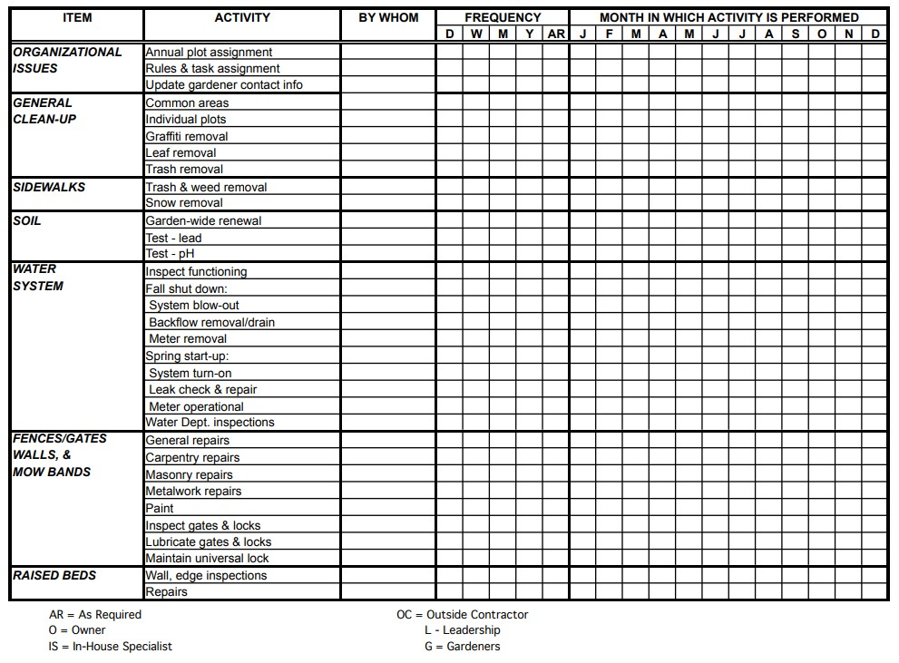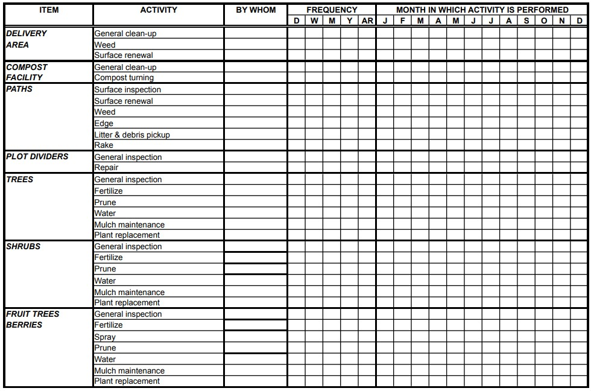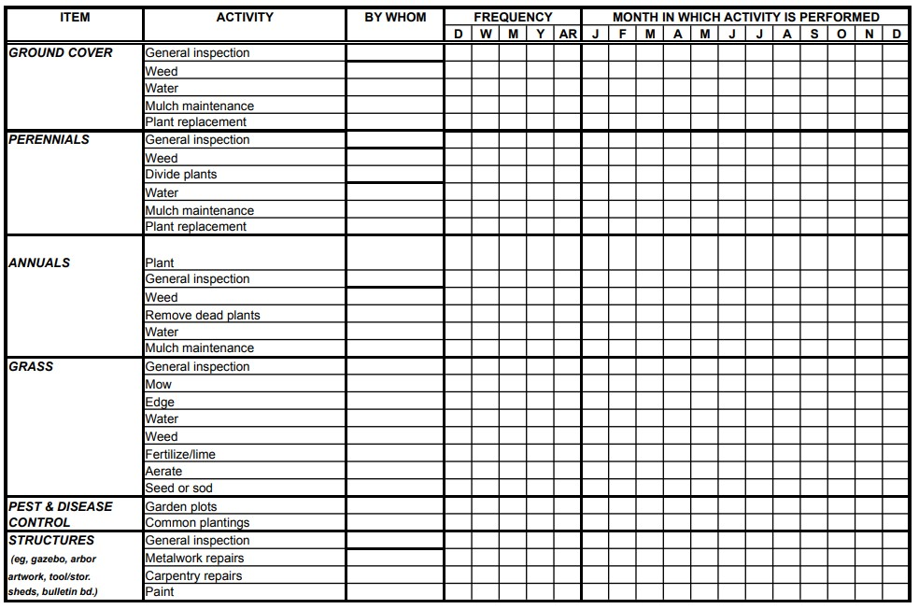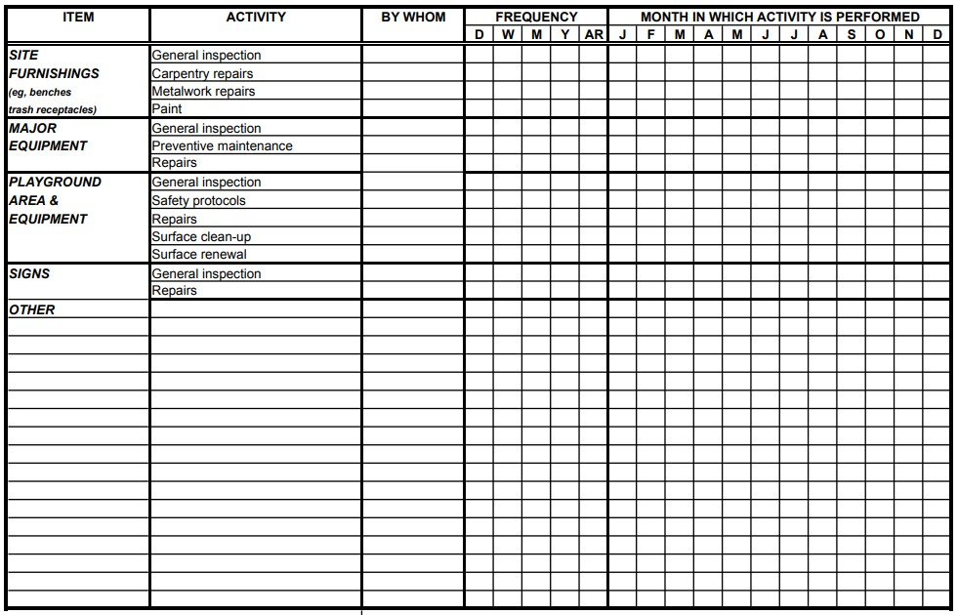

Conflict Resolution
Wherever there are people there will be differences to be had. Everyone is different and what makes sense to one person may be totally backwards to another. Laying down agreed upon ground rules and guidelines for the garden will help give everyone clarity on what is and what isn’t okay to do in the garden. Some common rules will set the times that people are allowed in the garden, whether or not non-organic inputs can be used, water usage, rights to fruits, veggies, and flowers, clean-up and winterization procedures, and other things that are expected of gardeners and guests while in the garden.
Strategies for resolving conflicts:
- “Looping” or repeating back statements. By actively listening and putting someone else’s words into your own understanding, it helps the other party feel like they have been heard and understood and helps the listener take in information and process it without instantaneously responding.
- Using “I” statements. Taking responsibility for our own thoughts, feelings, and actions instead of blaming others helps communicate those thoughts in a way that is less likely to cause anger or offense and mitigates strife and arguments. Avoid exaggerating.
- Don’t involve others where it is unnecessary. Have one-on-one conversations when possible concerning issues in the garden, and be direct, not passive aggressive. Public callouts and shaming are not helpful for resolving conflicts, these strategies usually only escalate problems further.

Important People

A community garden would be nothing without its community of people around it. There are several important people you will want to get involved in the project to help things run smoothly.
Starting with the most important person: YOU! People like you who are interested in starting a community garden and are willing to take the initiative and figure out how to make it happen are the most critical in the process of starting a community garden, or any kind of project really. By reading through this guide, you are already moving in the right direction. Hopefully the information provided in this guide will help you on the journey as you build a solid team around your community garden.
Other roles that can be important to fill include:
- Composting Coordinator: If you want to have a compost bin/pile, everyone involved in the garden needs to be educated and on the same page as to what can and cannot be put into the compost bin. You don’t want contaminants like plastics, trash, and toxic substances (or meat and dairy products if your compost method can’t process them safely) to ruin your entire batch of compost. You also want to maintain about a 1:1 ratio of “brown” materials to “green” materials, having someone to educate gardeners and neighbors and manage the composting process will be helpful.
- Social Coordinator: Have a social butterfly in the neighborhood? That person who knows everybody and their mother can be a great asset when it comes to planning meetings, get-togethers, and events for the garden.
- Treasurer: A designated, trusted person to handle the funds of the community garden and help plan budgets and apply for grants can be very helpful.
- Translators: Having people who can translate community garden news and information into multiple languages makes the garden more accessible to everyone in your community.
- Handyman: Someone who has experience building, welding, or fixing things and access to tools that they are willing to share for garden projects and upkeep. This person can be a lifesaver by making sure things are constructed correctly and safely.

(Quick) Resources
For more information, ideas, and help with you community garden project check out some of the many resources available to you in the Southcoast community, Massachusetts, Rhode Island, or online!
Other Community Gardens:
-Helfand Community Garden
318 Chase Rd, Dartmouth, MA
-Dartmouth YMCA Sharing the Harvest Community Farm
276 Gulf Road, Dartmouth, MA 02748
-Serenity Gardens
41 Bedford St. New Bedford, MA
-St. Andrews Church Community Garden
169 Belleville Rd, New Bedford, MA
-Riverside Park Community
297 Belleville Ave, New Bedford, MA
Run by Groundwork Southcoast
Organizations:
-Groundwork Southcoast
-SEMAP
-Brockton’s Promise Community Gardening Network
-UMASS Center for Agriculture, Food, and the Environment
-Soil Testing Service
-Southcoast Extension Service
-Mass Audubon
-Round the Bend Farm
-The Marion Institute

Programs:
URI Free Seed Program
Seed Libraries
Grants:
The Massachusetts Society for Promoting Agriculture
United Way of Greater New Bedford Changemaker Grant
New Bedford Massachusetts Cultural Council
-There is an MCC branch in each city, reach out to your city’s branch.
The Conservation Innovation Grant (CIG)
MA Food Security Infrastructure Grant
MA Urban Agriculture Program
SeedMoney
GroMoreGood Grassroots Grants
Whole Kids Garden Grant (For school/children’s community gardens)
Information:
Gardens Project – Has many good resources and guides for community garden management.
Community Garden Legal Toolkit
Justice Bridge – Offers free consultation with a lawyer that specializes in non-profits to help with legal questions
Farmer’s Almanac Planting Date Guide for New Bedford, MA
Accessibility Community Garden Guide by Grassroots Gardens of Buffalo – Many great building tutorials for different garden beds and containers!
American Community Gardening Association (ACGA)
UMass Extension’s Green Directory
Southcoast Community Garden – My YouTube channel, featuring the progress of the community garden I started while gathering all the information for this guide!

Sources
“5 Challenges of a Community Garden.” See What Grows Foundation, 6 Apr. 2015, http://seewhatgrows.org/5-challenges-community-garden/.
“2022 Planting Calendar: When to Start Vegetable Seeds | The Old Farmer’s Almanac.” Almanac.Com, https://www.almanac.com/gardening/planting-calendar. Accessed 29 Apr. 2022.
“3000acres.” 3000acres, https://www.3000acres.org. Accessed 29 Apr. 2022.
“About.” Round the Bend Farm, https://roundthebendfarm.org/about/. Accessed 29 Apr. 2022.
“ABOUT.” Helfand Farm Community Gardens, https://helfandgardens.com/about-us/. Accessed 29 Apr. 2022.
“About Community Programs.” The Great American Rain Barrel, https://www.greatamericanrainbarrel.com/community/. Accessed 29 Apr. 2022.
America, Follow SarahSarahCo-founder at Groundwork!Sarah lived all over South, et al. “Composting and Coworking: True Sustainability.” Groundwork, 30 Oct. 2015, https://newbedfordcoworking.com/coworking-and-composting-true-sustainability/.
“American Community Garden Association.” ACGA, https://www.communitygarden.org. Accessed 29 Apr. 2022.
Applicant Training | GRANTS.GOV. https://www.grants.gov/web/grants/applicants/applicant-training.html. Accessed 29 Apr. 2022.
“Apply for the Urban Agriculture Program | Mass.Gov.” Mass.Gov, https://www.mass.gov/how-to/apply-for-the-urban-agriculture-program. Accessed 29 Apr. 2022.
Bain, Marc. “Americans Have Stopped Trying to Stuff More Clothes into Their Closets.” Quartz, 26 Feb. 2018, https://qz.com/1212305/americans-have-stopped-trying-to-stuff-more-clothes-into-their-closets/.
Bamberger, Don. Interview with Don Bamberger. Oral, Mar. 2022.
Borges, David R., et al. Southcoast Health Community Needs Assessment. Umass Dartmouth Public Policy Center, 2019, https://www.southcoast.org/wp-content/uploads/2022/02/Southcoast-Health-CHNA-2019-Final_PPC-1.pdf.
“Boston Natural Areas Network.” Henry P. Kendall Foundation, 29 July 2013, https://www.kendall.org/boston-natural-areas-network/.
Bravo, Melissa. A Guide for Making Community Gardens Accessible for All Members. Grassroots Gardens of Buffalo, 2015, https://vcgn.org/vcgn2020/wp-content/uploads/2018/05/AccessibleCommunityGardensGuide-GrassrootsGardensofBuffalo.pdf.
Brister, Ashley. Interview with Ashley Brister. Oral, Feb. 2022.
“Brockton’s Promise Community Gardening Network.” Brockton’s Promise Community Gardening Network, https://brocktonspromisegardens.weebly.com/. Accessed 29 Apr. 2022.
Castelo, Jeremiah. “Is It Illegal to Collect Rainwater: 2022 Complete State Guide – World Water Reserve.” World Water Reserve, 29 Jan. 2022, https://worldwaterreserve.com/is-it-illegal-to-collect-rainwater/.
Cat, Deanna. “How to Fill a Raised Garden Bed: Build the Perfect Organic Soil.” Homestead and Chill, 22 Mar. 2019, https://homesteadandchill.com/how-to-fill-raised-garden-bed-perfect-organic-soil/.
“Climate & Weather Averages in New Bedford, Massachusetts, USA.” Time and Date, https://www.timeanddate.com/weather/usa/new-bedford/climate. Accessed 29 Apr. 2022.
“Communities.” Mass Cultural Council, https://massculturalcouncil.org/communities/. Accessed 29 Apr. 2022.
“Community Benefits Reporting in MA & RI.” Southcoast Health, https://www.southcoast.org/community-benefits/community-benefits-reporting/. Accessed 29 Apr. 2022.
Cortez, Summer, et al. “Gardening During Covid-19: Experiences from Gardeners Around the World.” UC Agriculture and Natural Resources, no. 6720, 2022, https://anrcatalog.ucanr.edu/pdf/6720.pdf.
DIY Raised Bed Manual. The Food Project, Apr. 2012, https://thefoodproject.org/wp-content/uploads/2019/06/DIY-bag-manual.pdf.
Domoney, David. “Funding and Donations for Your School or Community Garden.” Cultivation Street, 18 Feb. 2019, https://cultivationstreet.com/funding-and-donations-for-your-school-or-community-garden/.
Eggleston, Jonathan, et al. The Wealth of Households 2017. Census.gov, 2017, https://www.census.gov/content/dam/Census/library/publications/2020/demo/p70br-170.pdf. P70BR-170.
Find a Garden | SEMA Food Security Network. https://semafoodsecurity.com/community-gardens/. Accessed 29 Apr. 2022.
Food Security Infrastructure Grant Program | Mass.Gov. Mass.gov, 2022, https://www.mass.gov/service-details/food-security-infrastructure-grant-program.
Freecycle: Front Door. https://www.freecycle.org/. Accessed 29 Apr. 2022.
Ground Rules: A Legal Toolkit for Community Gardens. ChangeLab Solutions, 2012, https://www.changelabsolutions.org/sites/default/files/CommunityGardenToolkit_Final_%28CLS_20120530%29_20110207.pdf.
Groundwork Southcoast. https://groundworksouthcoast.org/. Accessed 29 Apr. 2022.
Growing Gardens in Urban Soils. Environmental Protection Agency, Spring 2011, https://www.epa.gov/sites/default/files/2014-03/documents/urban_gardening_fina_fact_sheet.pdf. EPA 542/F-10/011.
Home | GRANTS.GOV. https://www.grants.gov/web/grants/home.html. Accessed 29 Apr. 2022.
“Homeowners vs Renters Statistics [2022]: By Year + Demographic.” IPropertyManagement.Com, 10 Apr. 2022, https://ipropertymanagement.com/research/renters-vs-homeowners-statistics.
“How to Build Easy and Inexpensive DIY Raised Garden Beds.” The Frugal Homemaker, 13 Apr. 2020, https://thefrugalhomemaker.com/2020/04/13/how-to-build-easy-and-inexpensive-diy-raised-garden-beds/.
“How to Make Compost at Home | University of Maryland Extension.” University of Maryland Extension, University of Maryland, 22 Mar. 2022, https://extension.umd.edu/resource/how-make-compost-home.
“How to Start a Community Garden: Getting People Involved | UGA Cooperative Extension.” University of Georgia Extension, University of Georgia Extension, Mar. 2017, https://extension.uga.edu/publications/detail.html?number=B1399.
Howard, Ellie. “Victory Gardens: A War-Time Hobby That’s Back in Fashion.” BBC, 25 May 2020, https://www.bbc.com/travel/article/20200524-victory-gardens-a-war-time-hobby-thats-back-in-fashion.
“Invasive Species of Massachusetts.” Massachusetts Introduced Pest Outreach Project, MDAR, Jan. 2020, https://www.massnrc.org/pests/resources.htm.
King, Dan. Interview with Dan King. Oral, Feb. 2022.
“Lab Services.” Center for Agriculture, Food, and the Environment, University of Massachusetts, 20 Jan. 2017, https://ag.umass.edu/services/soil-plant-nutrient-testing-laboratory/lab-services.
“Learn How to Apply for the New England Farmer Microgrants Program.” American Farmland Trust, 2022, https://farmland.org/new-england-farmer-microgrants-program-how-to-apply/.
“Massachusetts Interactive 2012 USDA Plant Hardiness Zone Map.” Plantmaps.Com, //www.plantmaps.com/interactive-massachusetts-2012-usda-plant-zone-hardiness-map.php. Accessed 29 Apr. 2022.
“MMGA - Gardening Resources.” Massachusetts Master Gardener Association, 2021, https://www.massmastergardeners.org/gardening-resources.
Mobilian, Julianne. “Scotts Miracle-Gro Shares Uptick of Gardening Statistics Related to COVID-19.” Garden Center Magazine, 8 June 2020, https://www.gardencentermag.com/article/scotts-miracle-gro-shares-gardening-statistics-covid-19/.
“New Bedford Recycling Now Offering Two Types of Compost Bins for Sale to New Bedford & Dartmouth Residents.” New Bedford Guide, 9 Apr. 2021, https://www.newbedfordguide.com/new-bedford-recycling-compost-bins-for-sale-residents/2021/04/09.
New Stories From “Urban Agriculture Notes” — City Farmer News. https://cityfarmer.info/. Accessed 29 Apr. 2022.
“Online Banking FAQs | Donations & Sponsorships.” BayCoast Bank, https://baycoast.bank/community/donations-and-sponsorships/faq/. Accessed 29 Apr. 2022.
Overview - Public Infrastructure - City of New Bedford Official Website. https://www.newbedford-ma.gov/public-infrastructure/water/overview/. Accessed 29 Apr. 2022.
Perks, Stephanie. Interview with Stephanie Perks. Email, Apr. 2022.
Perry, Jean. “Community Garden Seeks New Home.” The Wanderer, 22 Oct. 2017, https://www.wanderer.com/features/community-garden-seeks-new-home/.
Phytotechnologies for Site Cleanup. Environmental Protection Agency, Sept. 2010, https://clu-in.org/download/remed/phytotechnologies-factsheet.pdf.
Polanz, Jennifer. “Decisions by Data.” Green Profit, 1 Mar. 2021, https://www.greenprofit.com/Article/?articleid=25148.
Products. https://blackearthcompost.com/compost-products/. Accessed 29 Apr. 2022.
Raposa, Ben. Interview with Ben Raposa. Oral, Jan. 2022.
“SeedMoney Offers Funding for Food Gardens.” SeedMoney, https://seedmoney.org/. Accessed 29 Apr. 2022.
“SF Nonprofit | Organic Farm | The Garden Project.” Thegardenprojectnew, https://www.gardenproject.org. Accessed 29 Apr. 2022.
“Sharing the Harvest Community Farm.” YMCA Southcoast, https://ymcasouthcoast.org/locations/dartmouth/sharing-the-harvest-community-farm/. Accessed 29 Apr. 2022.
Sheehan, Author Lindsay. “8 Cheap DIY Fence Ideas Anyone Can Build.” Rural Sprout, 6 Jan. 2020, https://www.ruralsprout.com/inexpensive-diy-fence-ideas/.
The Marion Institute. 26 Apr. 2016, https://www.marioninstitute.org/.
Thompson, Richard. “Gardening for Health: A Regular Dose of Gardening.” Clinical Medicine, vol. 18, no. 3, June 2018, pp. 201–05. DOI.org (Crossref), https://doi.org/10.7861/clinmedicine.18-3-201.
“URI Free Seed Program.” URI Master Gardener Program Cooperative Extension, 2022, https://web.uri.edu/mastergardener/freeseeds/.
“View Opportunity | GRANTS.GOV.” Grants.Gov, 2022, https://www.grants.gov/web/grants/view-opportunity.html?oppId=338670.
“Web Soil Survey - Home.” Web Soil Survey, USDA, 31 July 2019, https://websoilsurvey.nrcs.usda.gov/app/.

